OUTAGAMIE COUNTY GREENWAY FUND APPLICATION
The Outagamie County Department of Development and Land Services established the Greenway Fund Program to provide grants to local governments within Outagamie County for capital expenditures supporting greenway implementation.
Our definition of greenway is as follows:
A greenway is a trail or collection of open spaces, usually continuous and linear in fashion, found in urban and rural settings, serving various purposes. Examples of greenways include, but are not limited to bicycle, pedestrian, and other networks (e.g., trails, paths, and lanes), as well as environmental corridors (e.g., wildlife, waterways, or other natural corridors).
The purpose of this program is to promote the development of new greenways in Outagamie County that are regional in nature. It is also to help implement the vision and goals of Outagamie County’s Bicycle and Pedestrian Plan:
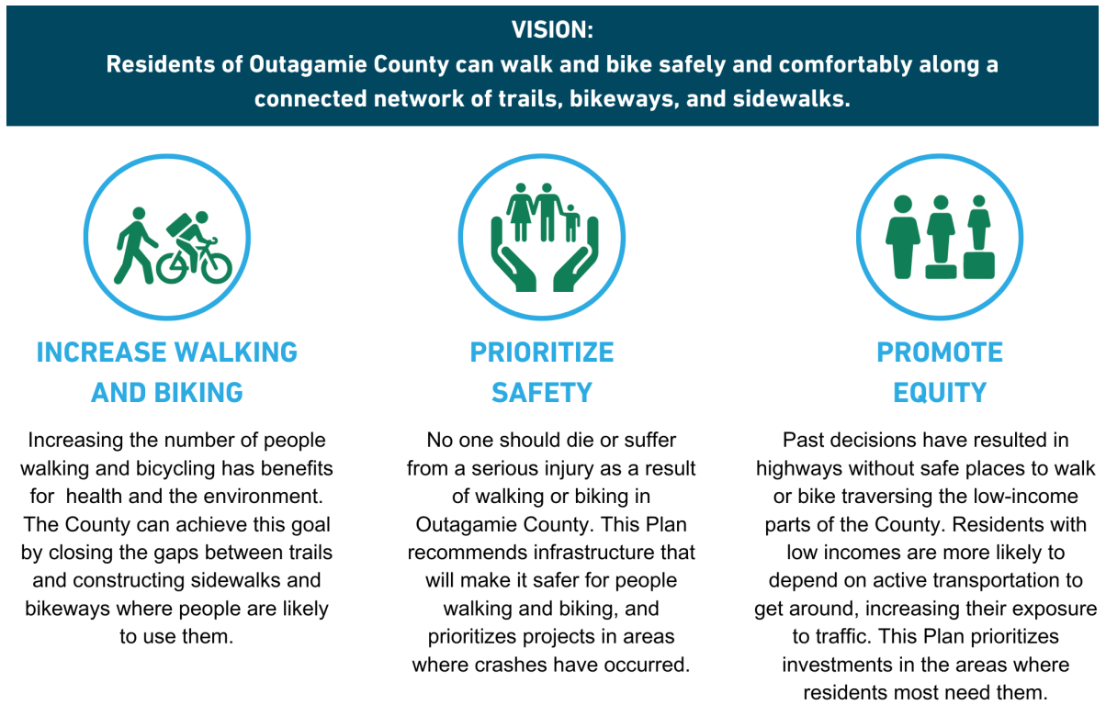

APPLICATION INSTRUCTIONS
- Review the “Grant Policies and Guidelines” as well as the “Greenway Fund Evaluation Form” for more information about project eligibility and the intent of the program. These documents are on the County’s website HERE.
- To apply for a project, complete the application beginning on Page 2 of this document. A sponsoring government unit may submit funding requests for multiple projects in a funding cycle. Please complete a separate application for each project request.
- Be sure to prepare and label all required attachments as specified in Part 4 of the application.
- Upon completion, submit your application online via CityView. A Quick Guide to submit your application is available HERE. There is no fee to submit an application.
- Please contact Sadie DiNatale Burda, Deputy Director, with questions or concerns at (920) 832-7821 or Sadie.DiNataleBurda@outagamie.org. You may request an optional pre-application meeting to discuss your project.

GREENWAY FUND APPLICATION

PART 1: APPLICANT INFORMATION AND CERTIFICATION
Project Title:
Sponsoring Governmental Unit:
Primary Contact - Name:
Title:
Phone Number:
Email:

Grant Amount Requested:
Total Project Budget:

The Applicant certifies, to the best of its knowledge, that the information submitted to Outagamie County in this application is true and correct. Furthermore, by submitting this application, the Applicant agrees to construct the greenway facility as outlined in the approved project plan and to assume responsibility for its ongoing maintenance to ensure that it remains safe, accessible, and in good condition for public use.
Printed Name:
Signature:
Date:

PART 2: PROJECT DETAILS
Please document the following key details about the proposed project:
General Project Location:
Project Dimensions:
(e.g., length, width)
Project Surface Materials:
Project Start Date:
Project End Date:
Estimated Useful Life (in years):

Please answer the following questions for the proposed project. If the response requires explanation, limit your response to a maximum of 100 words.
Has the entire project area been acquired for development? If no, please explain status. | ☐ Yes | ☐ No
Have all required permits for the project been obtained? If no, please explain status. | ☐ Yes | ☐ No

PART 3: PROJECT BENEFITS
Please answer the following questions, limiting each response to a maximum of 300 words.
What is the overall vision and description of the project?
For example, you may consider commenting on the purpose or goals of the project, anticipated outcomes, unique design features, landscaping elements, amenities (e.g., signage, benches, and lighting), special places the greenway passes (e.g., noteworthy natural, cultural, or geographic features), etc.

How does the project increase walking and biking?
For example, you may consider commenting on whether the route aligns with regional or local bicycle and pedestrian plans or comprehensive plans, connects to existing greenways, contributes to immediate or future connectivity with regional trail networks, improves accessibility for people of all ages and abilities, provides enhancements to encourage use, creates greenways in areas with high-demand for walking and biking, etc.

How does your project prioritize safety for users?
For example, you may consider commenting on whether the project is located in a documented high-crash area or corridor, creates safer crossings at streets, improves safe access to key destinations, improves the separation between modes of transportation (walking, biking, driving), enhances visibility, incorporates ADA-compliant features, addresses identified safety gaps, includes community input on safety concerns, etc.

How does your project promote equity?
For example, you may consider commenting on whether the project is located within a disadvantaged census tract or an ECWRPC designated equity priority area, its proximity to Valley Transit bus routes, and how it serves communities in need. You may consider identifying the primary users and beneficiaries of the greenway project, including those most impacted.

Why has the local jurisdiction prioritized this project above other community projects and/or greenway projects?

PART 4: REQUIRED ATTACHMENTS
The following attachments are required. Prepare each attachment accordingly to the instructions below.
- Attachment A: Project Map
  - Limit to one page, high-resolution, and legible at 8.5"x11" or 8.5"x17".
  - Show project location and boundaries clearly, with labels for major roads, landmarks, and nearby public destinations.
  - Indicate connections to existing greenways, trails, or parks, if applicable.
  - Distinguish proposed project from existing bicycle/pedestrian infrastructure.
  - Include a legend, scale bar, and north arrow.
- Attachment B: Timeline
  - Limit to one page, showing a detailed timeline from project start to completion.
  - Include key milestones with anticipated start and end dates. Milestones might include permitting, acquisition, pre-construction, construction phases, and final inspection.
  - Note any critical dependencies or seasonal factors affecting the timeline.
- Attachment C: Project Budget
  - Limit to one page, organized by budget categories (e.g., design & engineering, land purchases, permits, labor, materials, construction, contingency, other) with a total cost at the bottom.
  - List all committed funding sources and amounts to provide evidence of a fully funded project with balanced sources and uses of funds.
  - For projects within larger roadway construction projects, include only costs specific to the greenway.
- Attachment D: Letters of Support
  - Three letters of support are required.
  - Letters may derive from residents, businesses, and/or partner agencies or associations who understand the value of the project to the community, who provide financial support, and/or who provide advocacy for the project. Letters should not derive from the sponsoring government unit or Outagamie County.
- Attachment E: Conceptual Design or Plan – Optional
  - Limit to two pages.

