Grades 2-3
1st - #2 Vivian Dalton, Little Chute Flex Academy
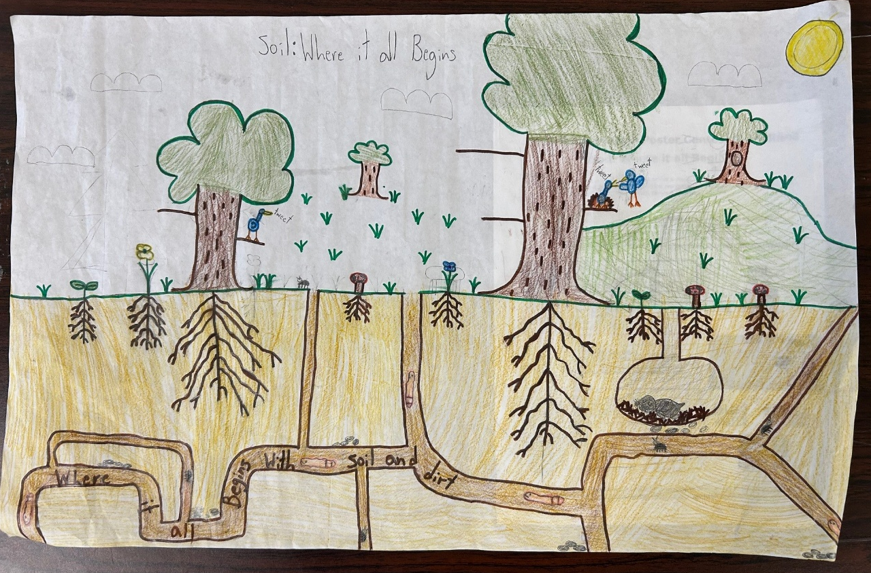

2nd - #3 Julianna Recla, Little Chute Flex Academy

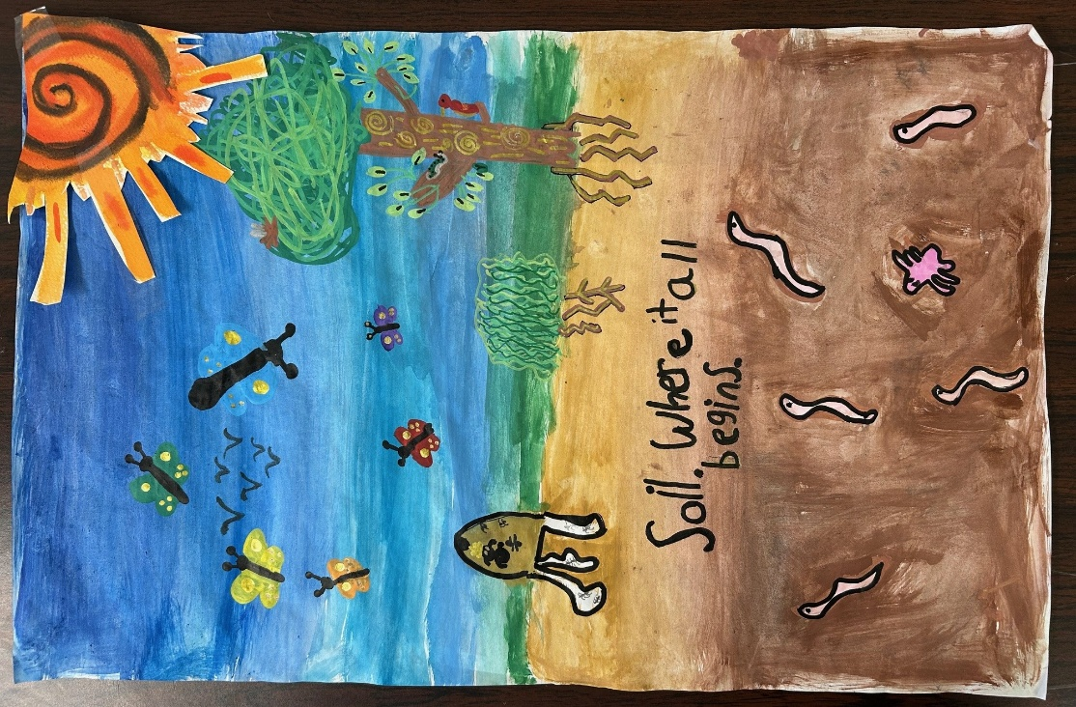

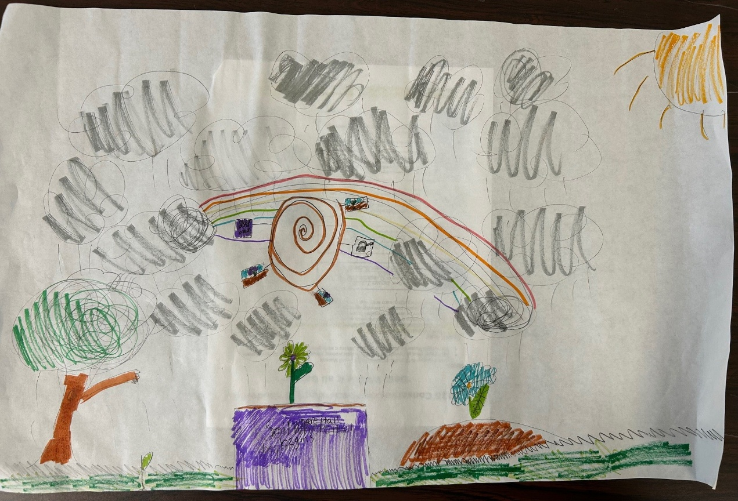
3rd - #1 Joanna Court, Little Chute Flex Academy

Grades 4-6
1st - #23 Natasha Gundrum, Little Chute Intermediate School
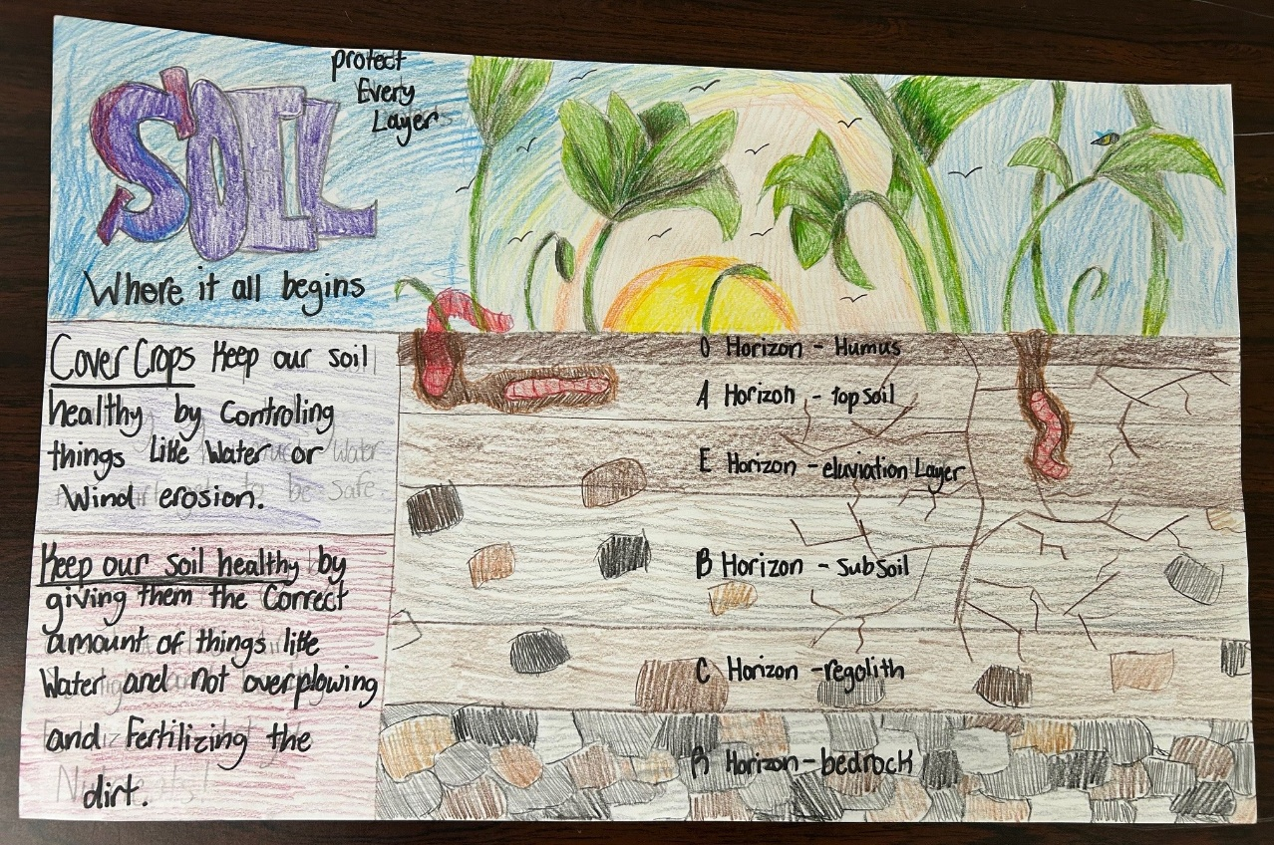

2nd - #29 Quintin Moreno, Little Chute Intermediate School



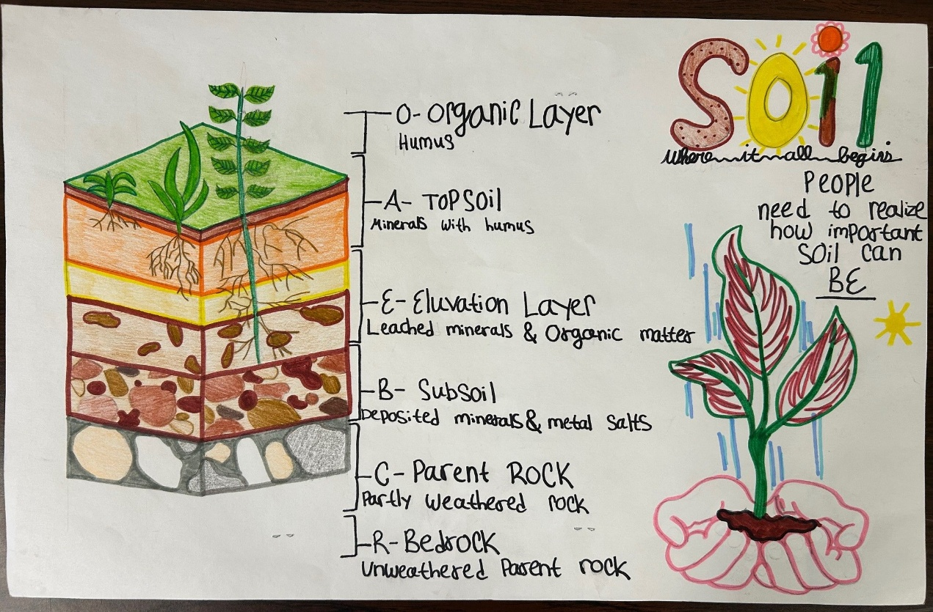
3rd - #30 Brielle Charles, Little Chute Intermediate School

Grades 7-9
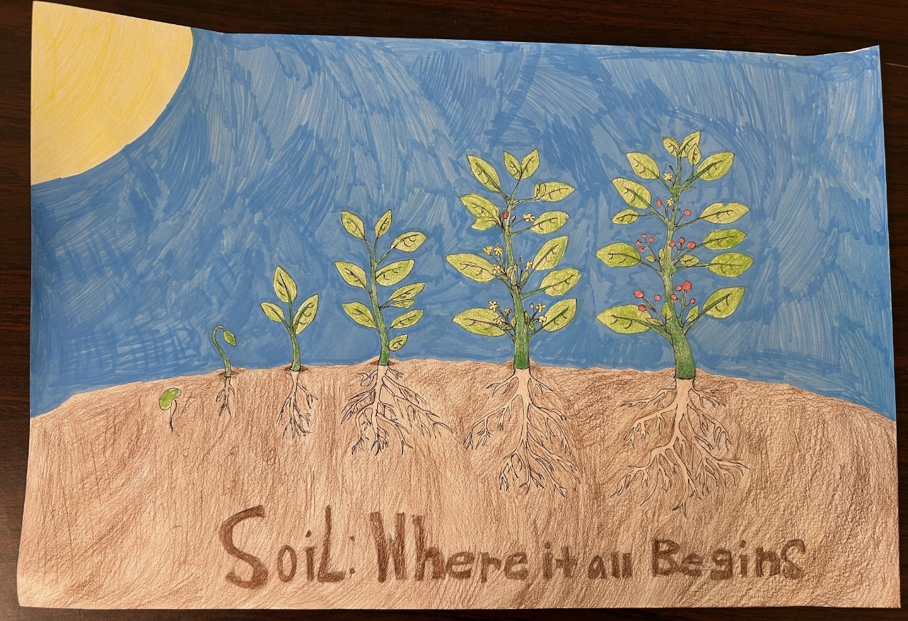
1st - #66 Ameenah Tinder, Fox River Academy

2nd - #64 Max Kilsdonk, Fox River Academy
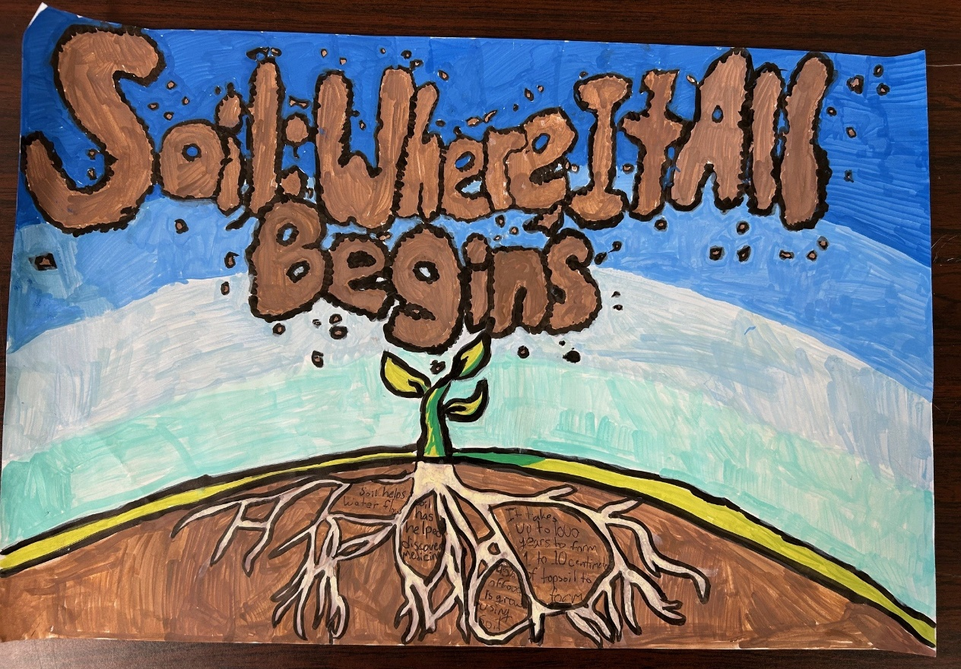

3rd - #65 Mauricio Yano, Fox River Academy
