ONLINE REAL ESTATE RECORDS TRACT INDEX


- (From LandShark), click on the ‘ColorTract’ link to go to: https://outagamie.colortract.com/

- Select a File Cabinet from the drop-down list and click on Submit:
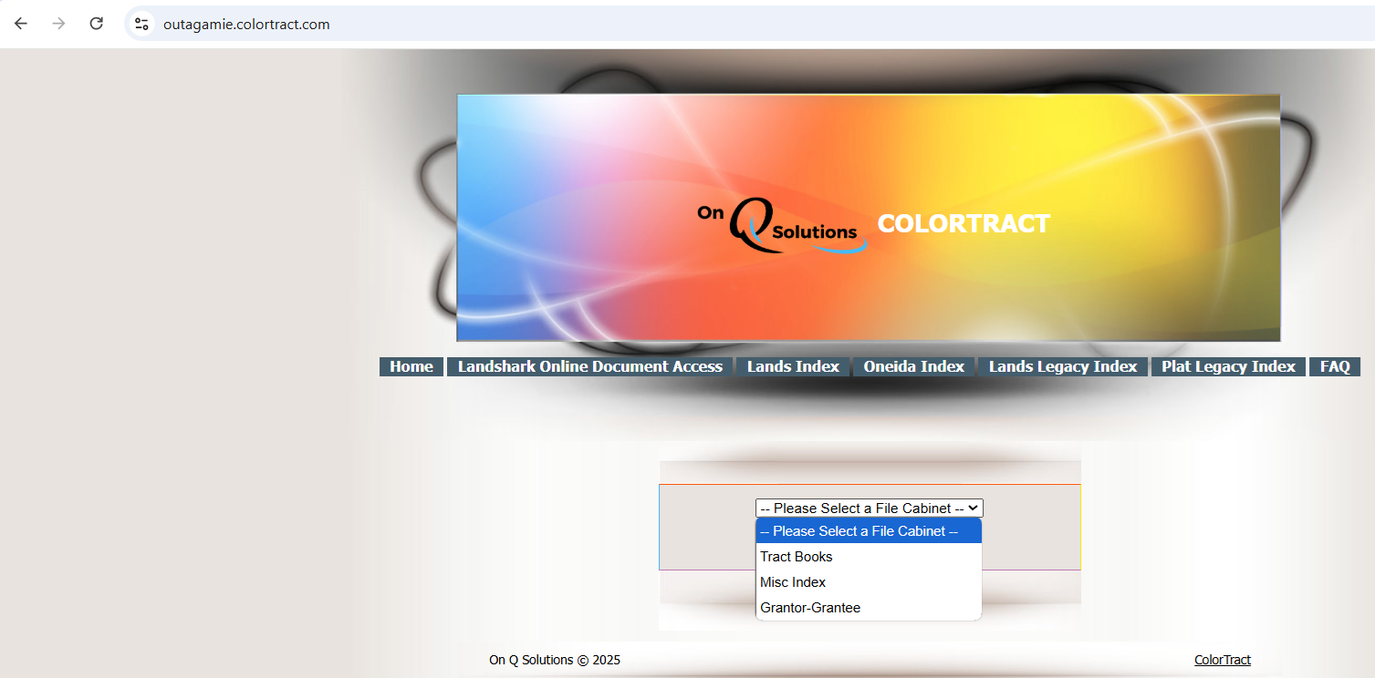
- Tract Books
- Misc Index
- Grantor–Grantee
Tract Books (index to land records going back as far as 1851. Must know the legal description of a property in order to begin search):
  - Select a File Drawer
    - Town Lots (all platted subdivisions in Outagamie County, except for City of Appleton and Town of Oneida)
    - City of Appleton (platted subdivisions only)
    - Lands (all metes & bounds descriptions)
    - Oneida (Town of Oneida only)
Misc Index (contains documents with vague legal descriptions or legal descriptions too extensive to be posted in tract index, (i.e., railroad docs, street vacations, annexations, etc. Discontinued posting to the Miscellaneous Index as of May 2022. Documents after that can be located in Tract Books):
  - Select a File Drawer
    - Miscellaneous Index
    - Search by Year, Alpha, or Volume 1 or 2
Grantor–Grantee:
  - Select a File Drawer
    - Pre-1879
    - Grantor Deeds
    - Grantor Mortgages
    - Grantee Deeds
    - Grantee Mortgages

For Tract Books search:

Tip: Use the Indexes (Lands, Oneida, Lands Legacy, Plat Legacy, etc.) to help determine Volume and Page numbers as a starting point in search values, if necessary

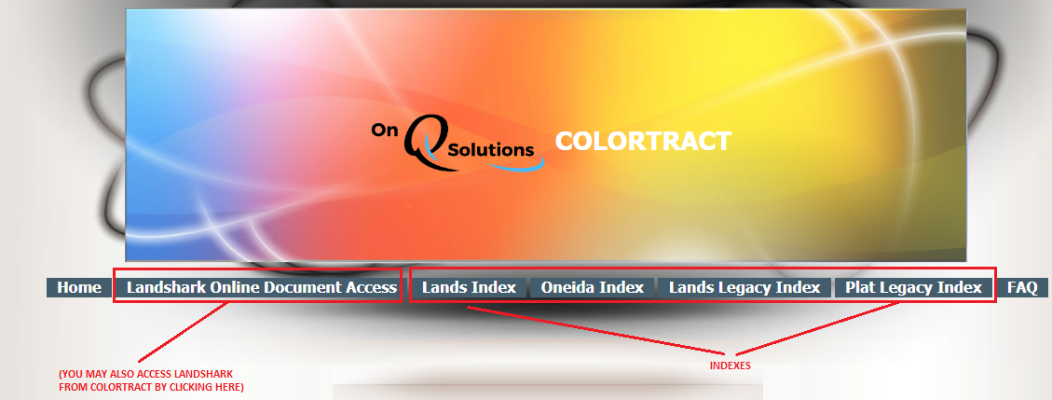

1) Enter Volume and Page number of tract book, if known, or if searching by Subdivision, select JUST the Subdivision name leaving all other drop-down fields empty

- If Volume & Page of Tract Book are known:
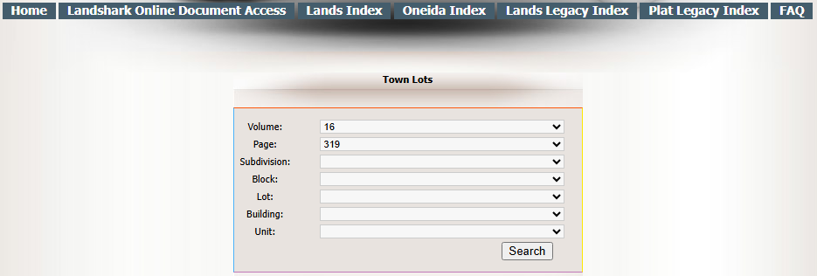

- If searching by Subdivision name, click in the Subdivision field and start typing the first few letters of the plat name to quickly jump to it (must also know Lot number and/or Block number)
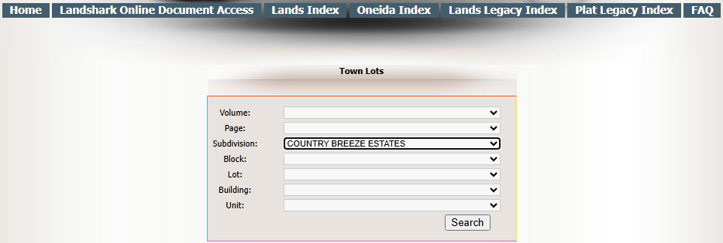

- Click on Search

2) Search results appear in lower left box

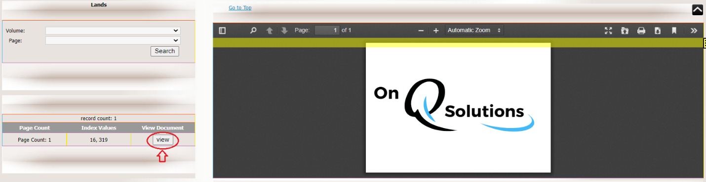

Or, if searching by Subdivision, (must also know Lot number and/or Block number)

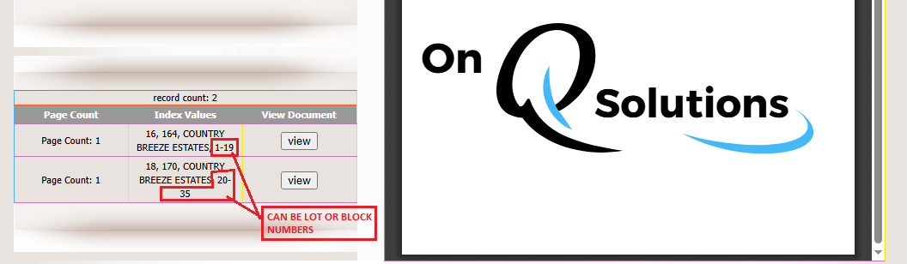

- Click on View

3) Maximize the viewer

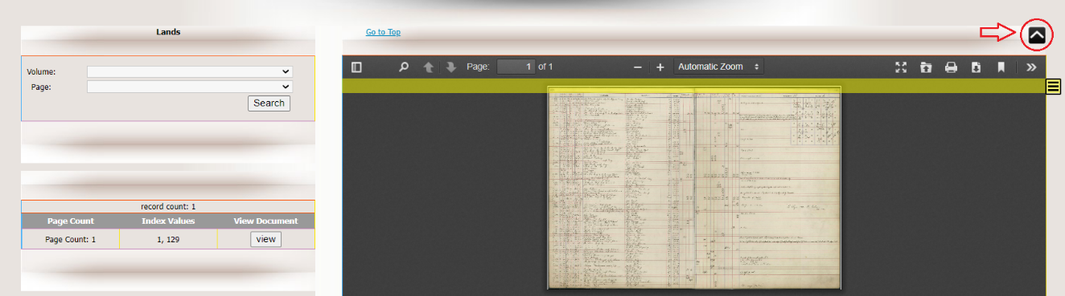

4) Adjust the Automatic Zoom option to resize the page

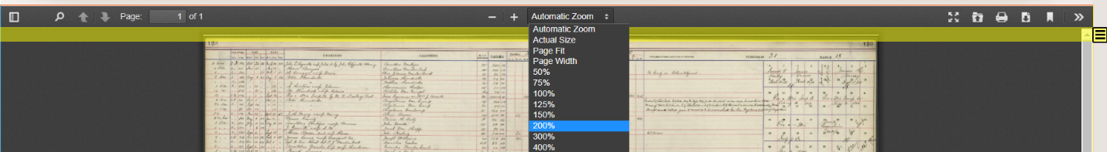

5) Locate and follow the column for specific lot/block, or “quarter-quarter” within a Section
- Documents tracted to that specific lot or section quarter may be indicated by an “x,” “Part,” or “All”
- When indicated, locate the type of instrument recorded by following that entry line to the left
- Type of Instrument will be indicated in the ‘Kind of Instrument’ column (e.g., WD = Warranty Deed; QCD = Quit Claim Deed; Ease = Easement; Mtg = Mortgage; Rel = Release…)

In this example, a Warranty Deed for Lots 20, 21, etc., can be found in Jacket 13544, Image 30
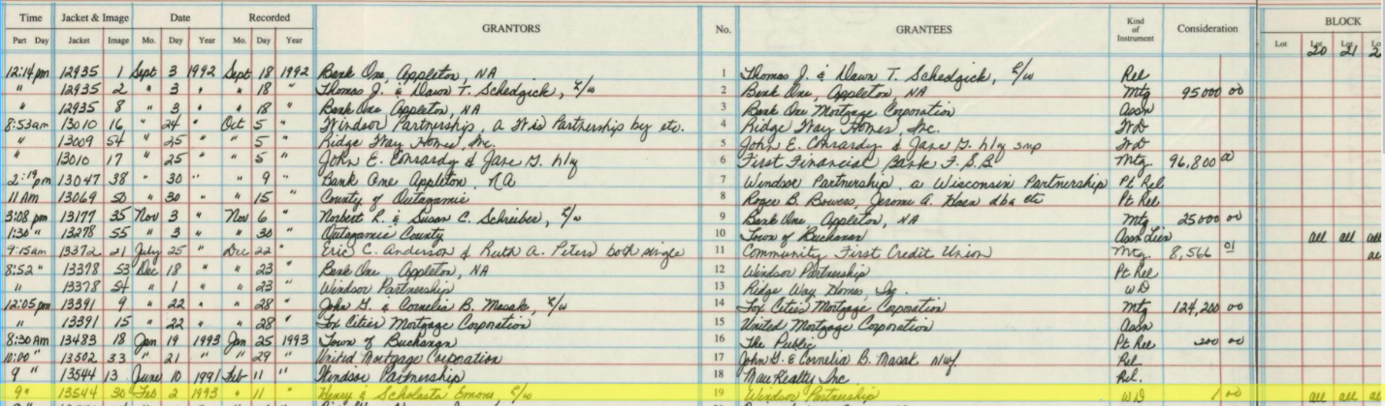

6) Obtain recording information to view images in LandShark
- Volume/Page or Jacket/Image recording information is located in the 2nd and 3rd columns on the left (Note: when searching in LandShark, Jacket and Image numbers are the same as Volume and Page numbers)

7) Follow the transferred from and transferred to information to go forward and back within the tract books (use browser ‘Back’ button to enter a new volume and page)

- Volume and Page numbers of tract book where transferred from = upper right-hand corner
- Volume and Page numbers of tract book where transferred to = mid to lower right-hand corner

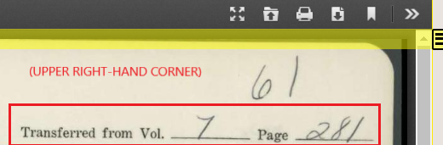

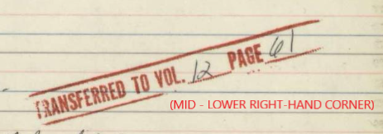

TIPS:
How to locate a tract book…
Before a parcel became overplatted (“where it came out of”)
  - You may need to switch tract books
  - Example: from ‘Town Lots’ to ‘Lands’ (indicated in upper right)
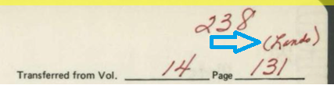

  - Example: CSMs (indicated above each column)
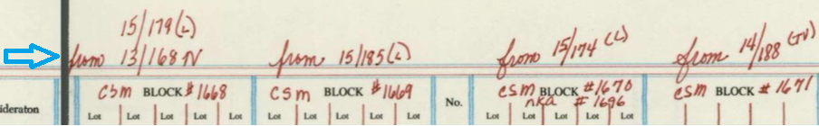

After a parcel has been overplatted
  - Go to the Vol/Page indicated in the Comments/Description/Remarks column
  - Example: Lots 17, 18, & 19 of Block 3, overplatted by a CSM
